How to Run the App

*Availability*

When using the availability section, note that you will need to click the ‘Update’ button for each day that you wish to update. You will also need to update a removal of a class before you can replace that class with another class.

*In-Built Interactions to Assist your Testing*

The current version of the application uses a local database. Cloud interactions are simulated by a function in App.Xaml.cs. To assist in your testing of the app, several interactions have been initialised, or have been prepared for you to run through.

Existing Accounts:

Jason: [jason@gmail.com](mailto:jason@gmail.com) 222222

Frank: [frank@gmail.com](mailto:frank@gmail.com) 333333

Both of these accounts have existing availability entries. They both have an IAB330 class on Tuesday at 11am and an offer from Frank to join a group for this subject has already been sent. If you accept this offer, you can test the Book Meeting functionality. You can also check that a confirmation of this acceptance is sent to Frank by logging in to his account after accepting as Jason. They also have a CAB403 class together on Thursday from 11, and this can be used to test the Find Team functionality.

*Versions*

The following versions were used for the Collaboro app.

Visual Studio: Visual Studio Community 2017 Version 15.8.4

Emulator: VisualStudio_android-23x86_phone with OS Marshmallow 6.0 – API 23

NuGet Packages:

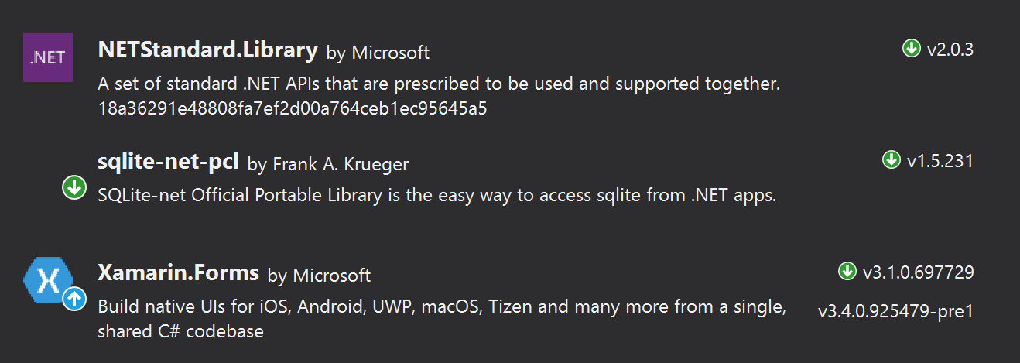

SDKs:

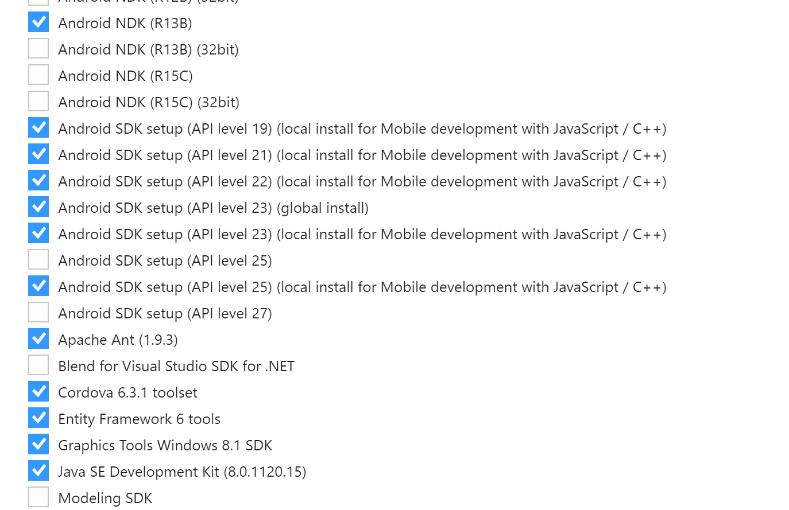

Note that not all of these SDKs are necessarily required to run the application.

*Troubleshooting*

If you wish to reset the in-built interactions to what they were on first start-up, or if you are encountering errors with the emulator not displaying despite the application running, it is recommended that you factory reset the emulator.

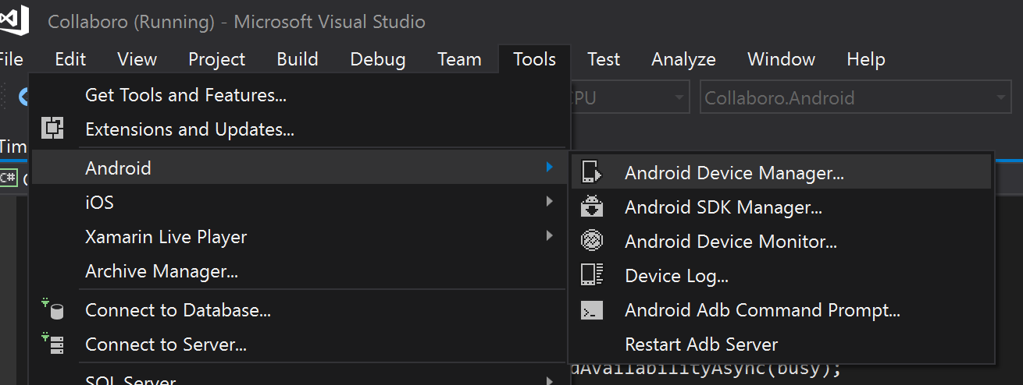

Go to Tools, Android and then Android Device Manager. You may get a pop-up asking if you wish for this to make changes to your system, which you should accept.

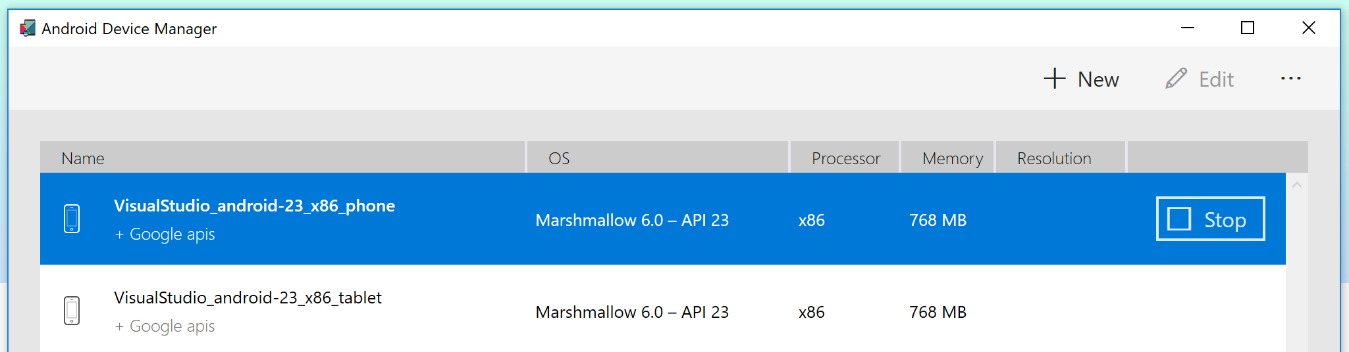

If your emulator is already running, click on the ‘Stop’ button. This will close the emulator.

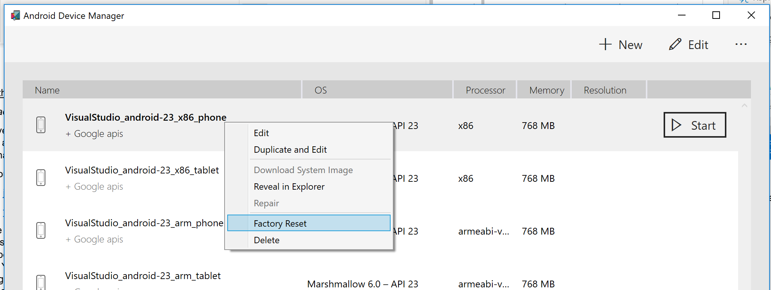

Right click on the emulator you’re using and select ‘Factory Reset’.

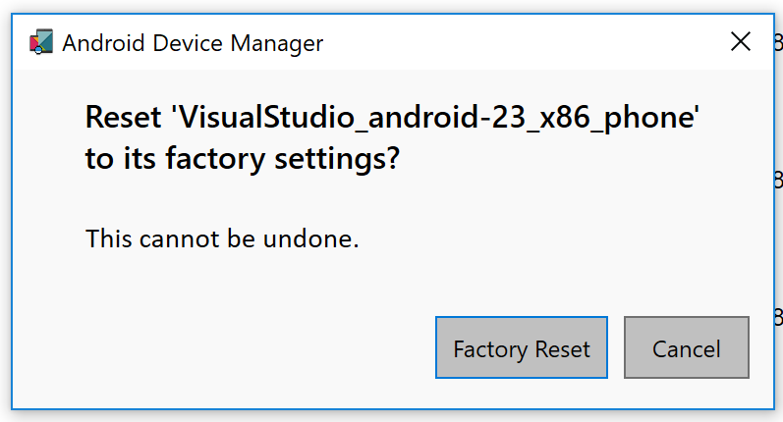

Click the ‘Factory Reset’ button in the popup. Then try running the emulator again. You may need to run it, close it and re-run it before it runs successfully.

Other troubleshooting suggestions include rebuilding the project (shown below), closing Visual Studio and restarting your device.

